**Open Source Vs Closed source:**

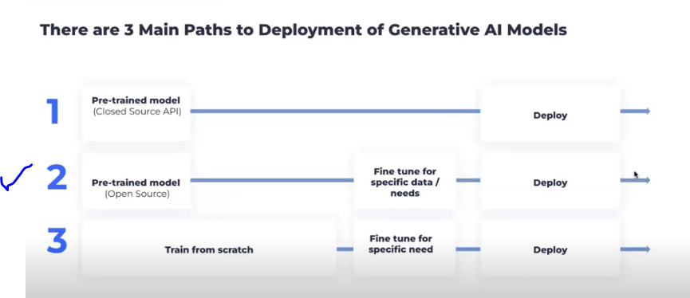

**Closed source model,** which we need to use directly via API. Security issue will be there, data will be exposed outside

**Open source model** which we can download and fine tune with our data and deploy

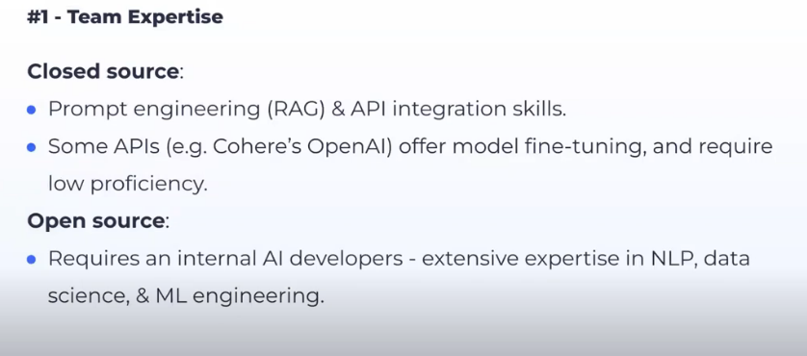

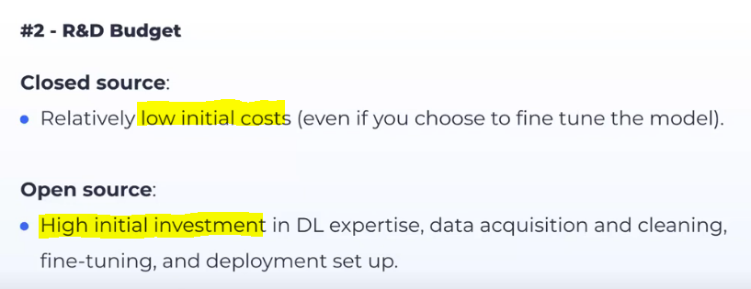

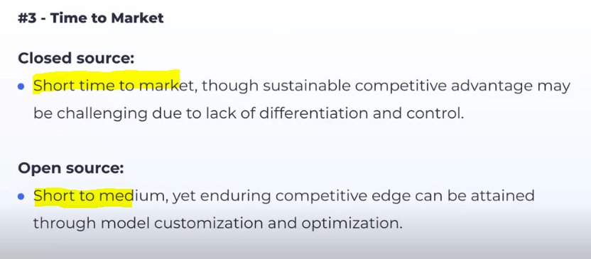

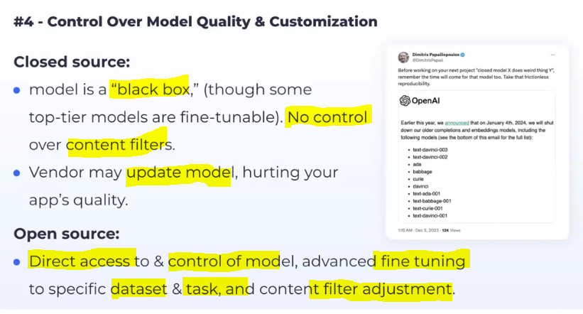

In Closed source, vendor some time decomission some models, this will impact our application which built on that.

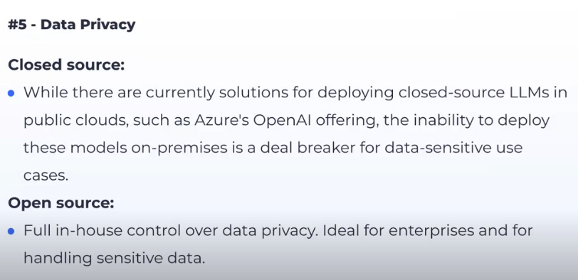

Normal Scenario, closed source model we connect via API to our cloud, so it will effect the data security and some time calling that API within our cloud provider will be risky, we may leak our data outside. But now a days Azure Openai provides LLM model within its cloud with full security. Now in Pru we are following same approach.

